Write the times shown below with numbers and by writing the number of minutes past the hour.
Can I tell the time to the nearest 5 minutes and draw the time to the nearest 5 minutes?
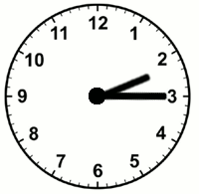  2:15 or  15 minutes after  2 o'clock | 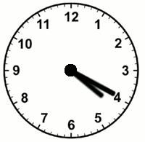  ______ or  ___ minutes after  __o'clock | 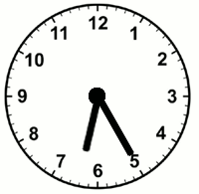  ______ or  ____ minutes after  __ o'clock
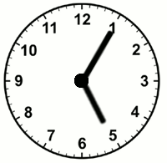  ______ or  __ minutes after  __ o'clock | 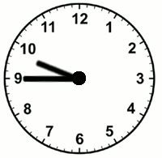  _____ or  ____ minutes after  ___ o'clock | 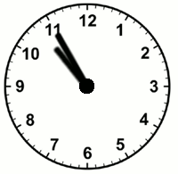  ______ or  ____ minutes after  ____ o'clock
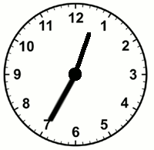  ______ or  ____ minutes after  ____ o'clock | 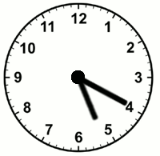  ______ or  ____ minutes after  ___ o'clock | 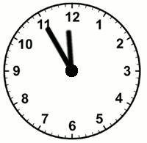  _______ or  ____ minutes after  ____ o'clock

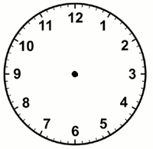
Can you draw the times on these clocks? Be careful with the hour hand – remember that it moves too!!!

10:05
2:35
6:55
7:20
Count around the clock by fives starting with 0 above the 12 hour number.
Can I count in 5s around the clock then use this to tell the time to the nearest 5 monutes?
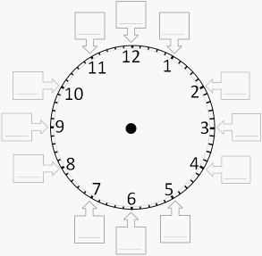
 | Write the times shown below with numbers and by writing the number of minutes past the hour.
2:15 |  | _________ | _________
__________ |  | __________ | __________
_________ |  | _________ | __________

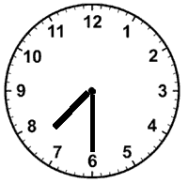  30  15  45  00  Can I tell the time to the hour, half and quarter hour?  Time is: 7:30  In words: Half past 7. | 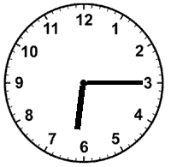  Time is: _______  In words: ____________________
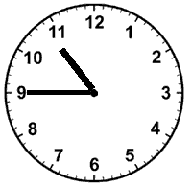  Time is: _______  In words: ____________________ | 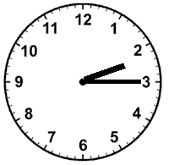  Time is: _______  In words: ____________________
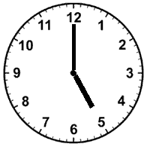  Time is: _______  In words: ____________________ | 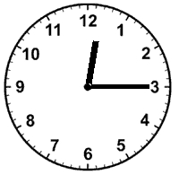  Time is: _______  In words: ____________________
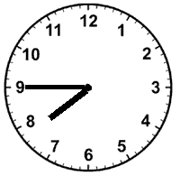  Time is: _______  In words: ____________________ | 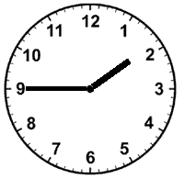  Time is: _______  In words: ____________________

