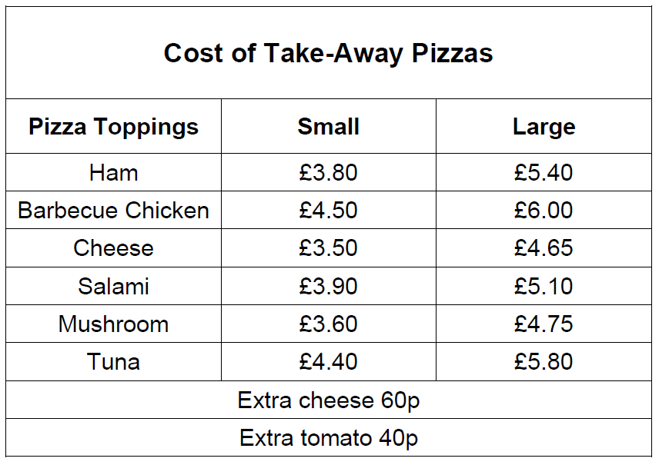

Find the cost of:
- One small mushroom pizza with extra cheese and tomato topping.
- Two large cheese pizzas and one small chicken pizza.
- A small ham pizza with extra cheese and a large tuna pizza with extra tomato.
- A large salami pizza with extra cheese and two small cheese pizzas, one with extra tomato.
Sue and Ravi want to buy one large pizza with extra cheese and one small pizza with extra tomato. They have £10 between them. Which pizzas can they buy?
