Research seaside animals. Either write some facts or draw the animals and label.  Maple Class Summer Term Homework.  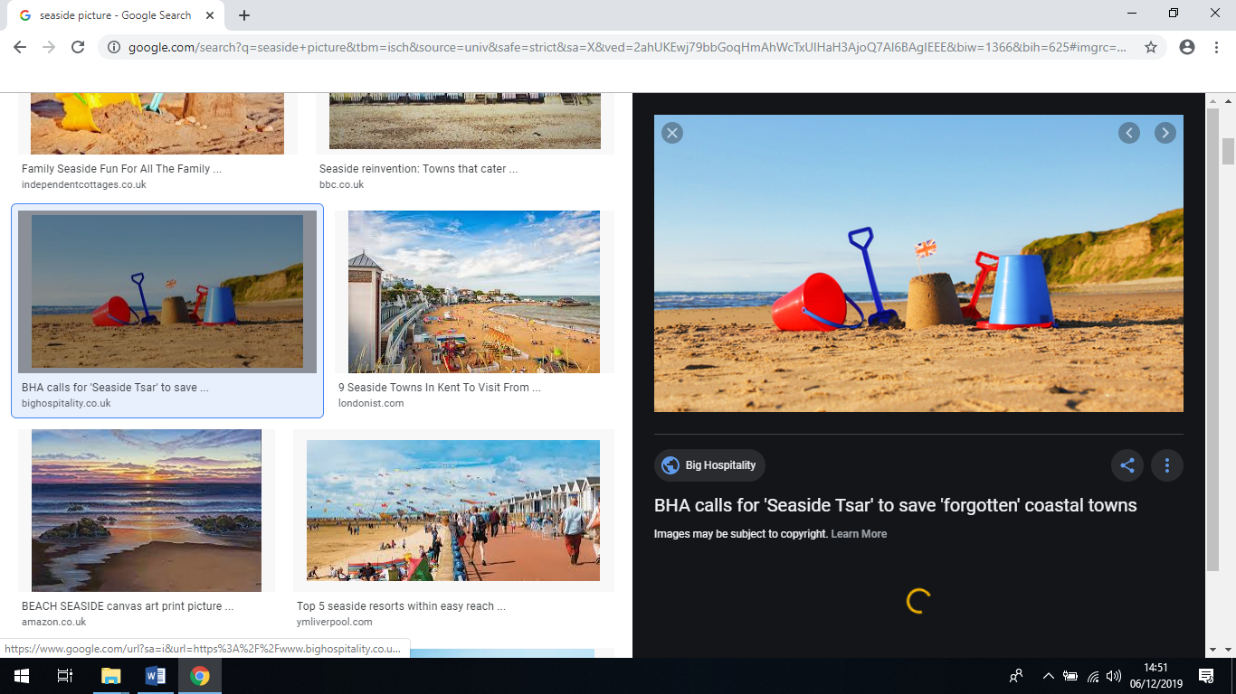 | Geography  Can you make a poster comparing different seaside locations in UK? | Art  Design your own sea creature by drawing, painting or using collage. | History  Make a postcard advertising a seaside holiday  in the past.
DT  Take a trip to the beach or just a sandpit and build a sandcastle. | English  Imagine you are at the seaside. What can you hear? See? Smell? Touch? Taste? Write a description of it. | Music  ‘A sailor went to sea, sea, sea…’ is a sea chantey. Make up your own. You could keep the same melody and change the words or create a brand new one. | Art/DT  Design your own seaside fairground ride. Can you make it out of junk modelling?
Art/DT  Design a new flavour of ice cream or a new ice lolly to be enjoyed on hot summer days by the seaside. | Geography  Think of two different seaside towns you have visited. Write down their similarities and differences. | Beach Safety  Discover how to be safe at the seaside. Write a list of rules you could share with other children on how to keep safe. | Outside the environment  Find out how pollution affects the seaside. Make a poster to tell people about it.
Creative arts  Create your own Punch and Judy characters and a script. | Topic  Design a questionnaire for an older relative about their childhood seaside holidays. | Science  Find out about the rock pool habitat. Draw and label all the fascinating plants and creatures. | Choose your own activity… x2

