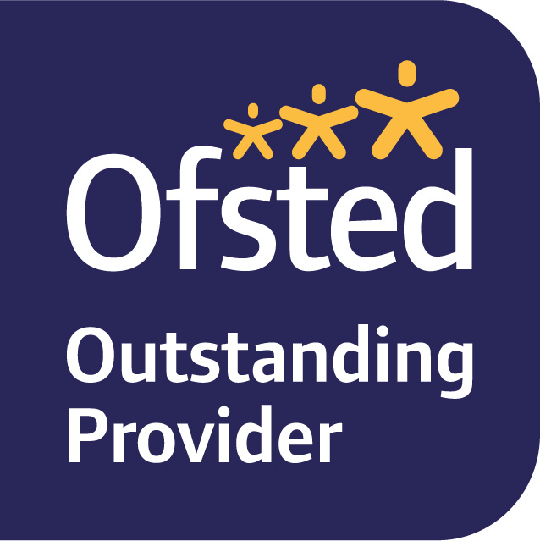

# INGOLDISTHORPE C of E PRIMARY SCHOOL



Shernborne Road, Ingoldisthorpe, King’s Lynn, Norfolk PE31 6PE

Telephone: 01485 541402 Fax: 01485 544915

Email: [head@ingoldisthorpe.norfolk.sch.uk](mailto:head@ingoldisthorpe.norfolk.sch.uk)

*“A family school where everyone matters”*

10th October 2018

Dear Parents,

**Oak Class - Residential Visit 27.02.19 - 01.03.19 – Aylmerton Field Study Centre**

We have booked a residential visit for Oak Class to Aylmerton Field Study Centre in February 2019. The children will be transported to and from the centre by coach. The visit is for two nights and three days and is fully catered by the field study centre.

The cost of the trip is £144.00 per child. This includes travel, accommodation, fully catered meals and all activities during our stay. We request a non-refundable deposit of £36.00 to secure your child’s place. The balance can be paid in three instalments of £36.00 or via school money, or if you prefer a one-off full payment to the office.

Accompanying the children will be Mr Wright, Mrs Taylor and Ms Hall. Mrs Taylor will be holding a parents’ meeting after Christmas to inform you of the planned activities and answer any questions you may have.

Yours sincerely,

Mr Wright

……………………………………………………………………………………………….

**Oak Class - Residential Visit 27.02.19 – 01.03.19 – Aylmerton Field Study Centre**

I/we give permission for our child ………………………………………to attend the above residential visit and we agree to pay the non-refundable deposit of £36.00 via schoolmoney/cheque to the office. The balance will be paid in full before 15.02.19

Signed………………………………………………………Dated………………………..