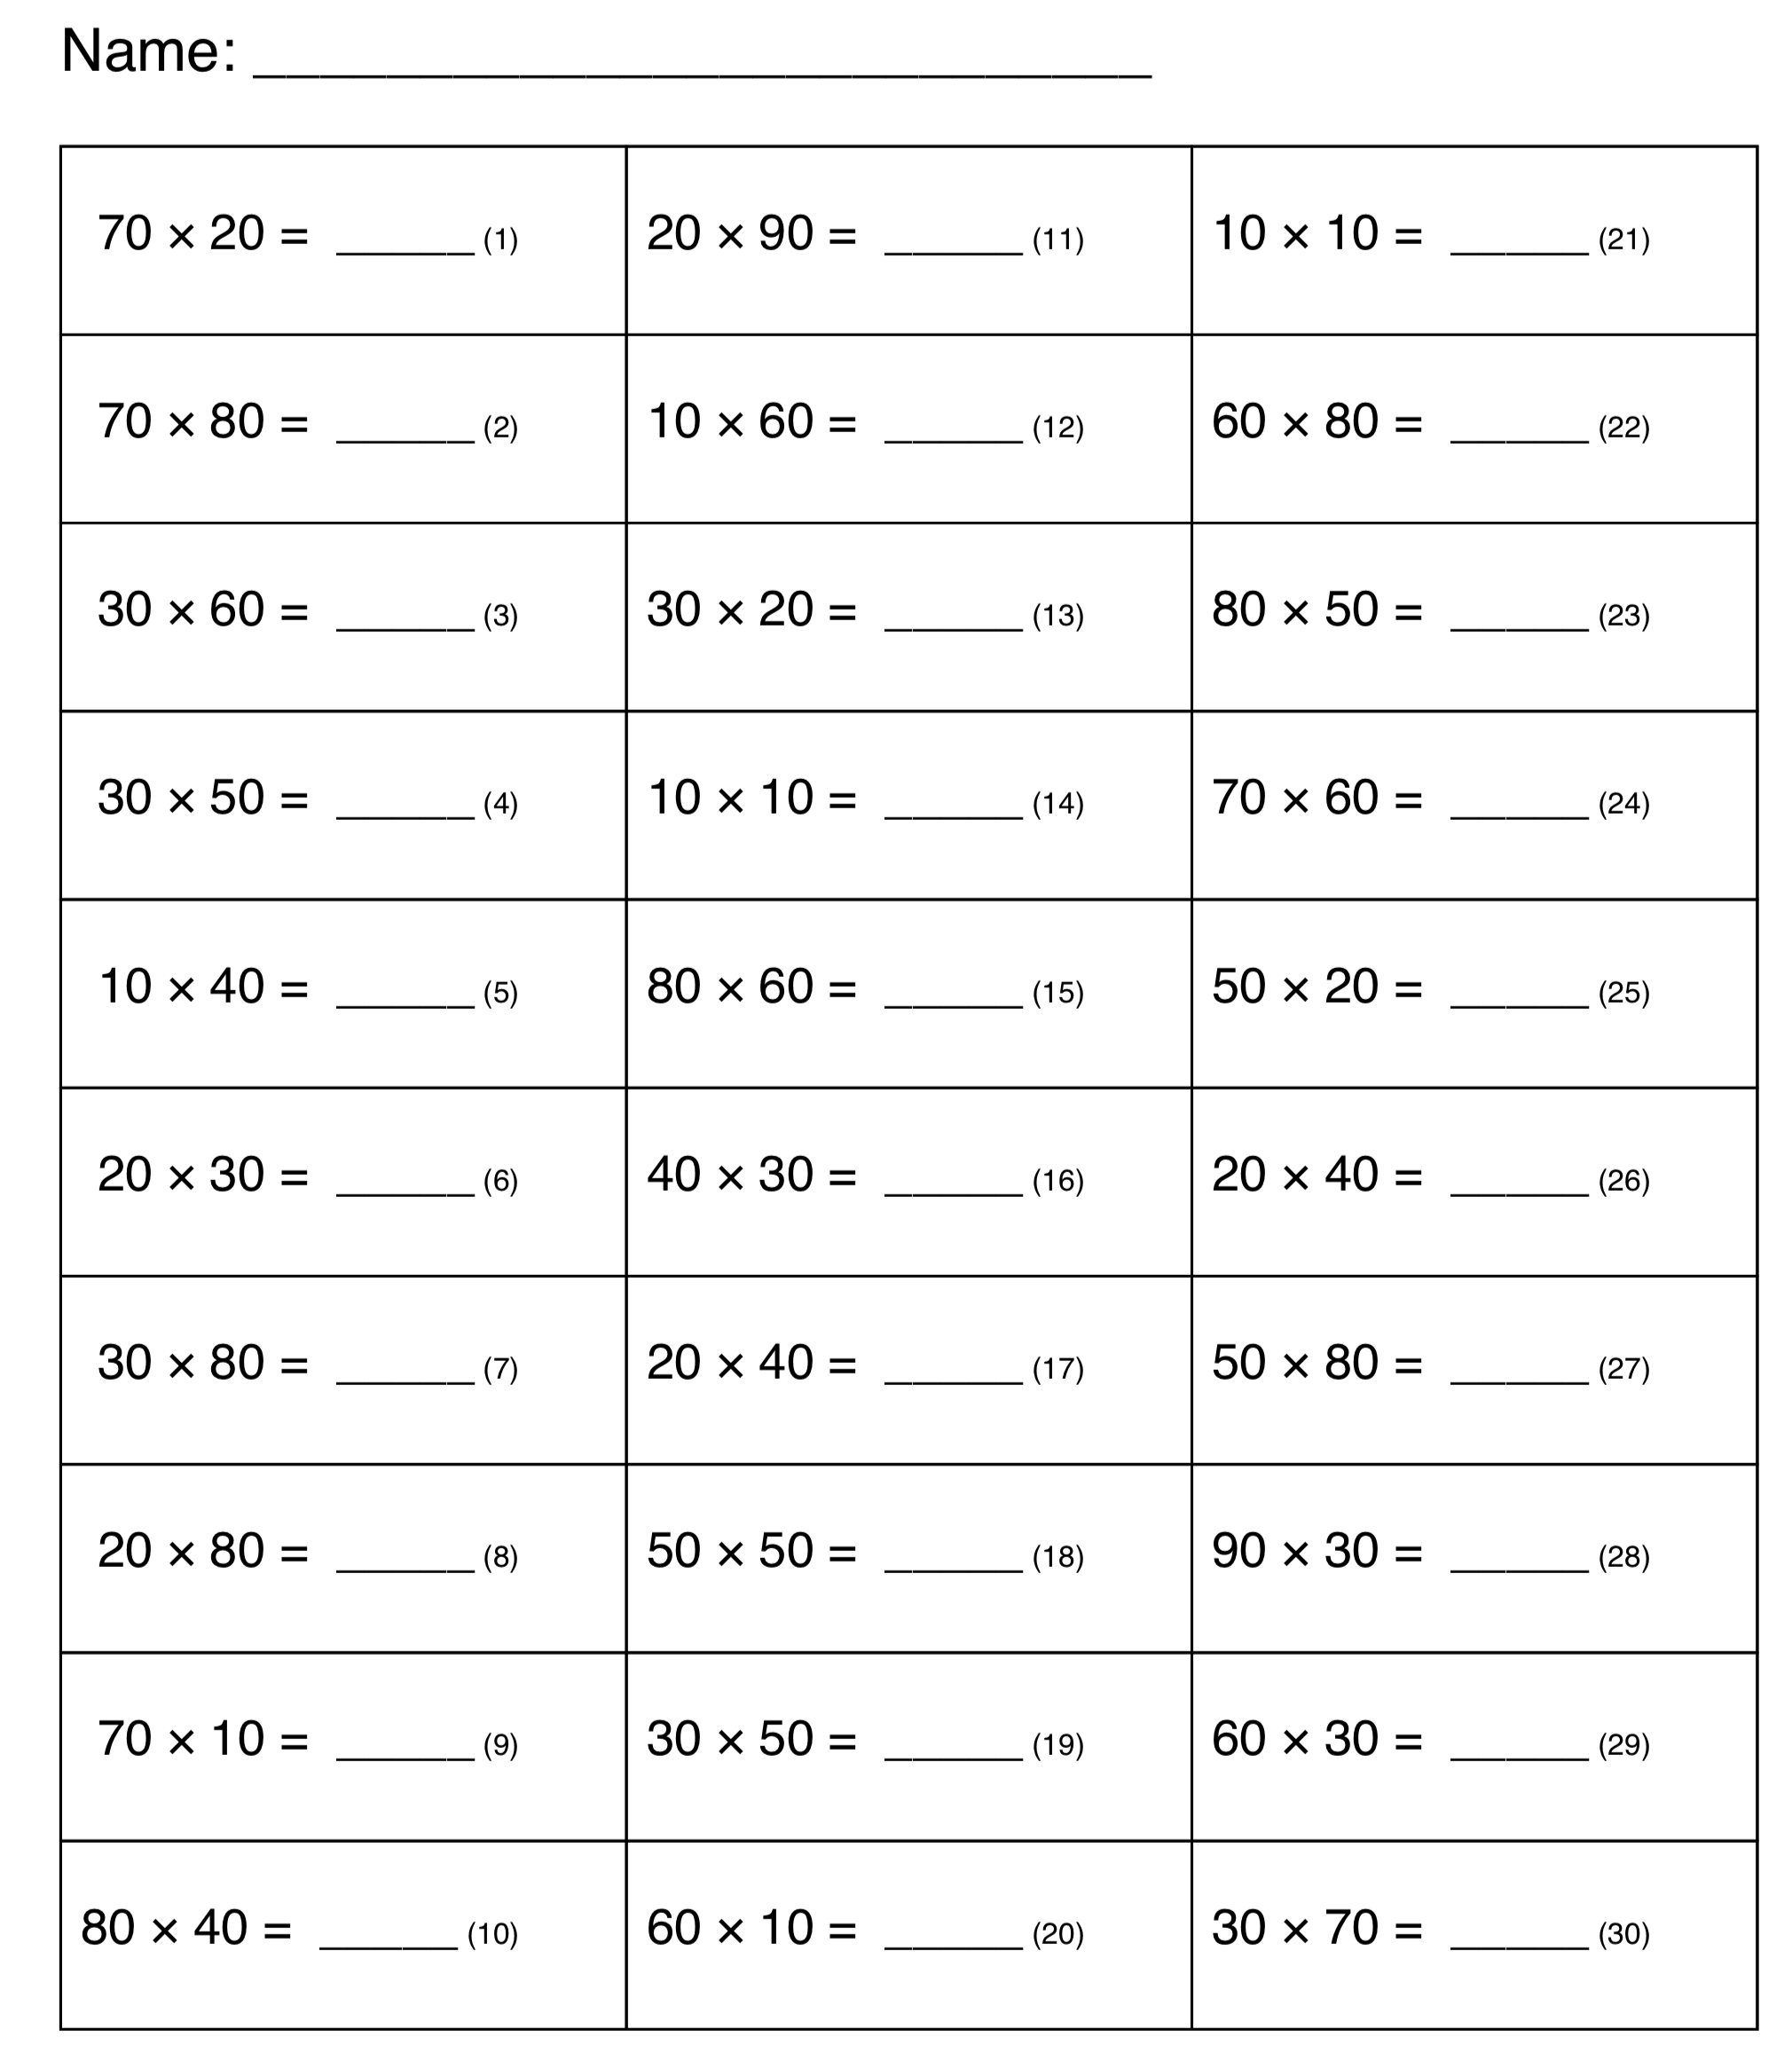
- 534 + 876 =
- 1245 + 7365 =
- 243 – 143 =
- 6542 + 6532 =
- 5427 + 9872 =
- 76 x 5 =
- 43 x 6 =
- 6543 x 8 =
- 6542 + 76549 =
- 6529 – 7512 =
- 5882 – 4132 =
- 654 x 6 =
- 76542 x 3 =
- 6542 – 981 =
- 5498 + 622 =
- 61187 – 52287 =
- 789 + 212 =
- 652 + 21654 =

