Yr. 3 Put these numbers in order from smallest to largest
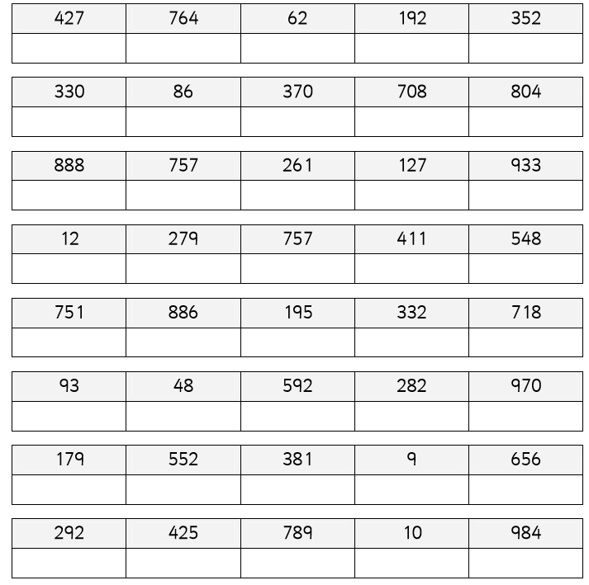
Example
230 | 142 | 256 | 92 | 190
92 | 142 | 190 | 230 | 256

Yr. 4 Put these numbers in order from smallest to largest
Example
2302 | 2142 | 3256 | 1292 | 2190
1292 | 2142 | 2190 | 2301 | 3256

