[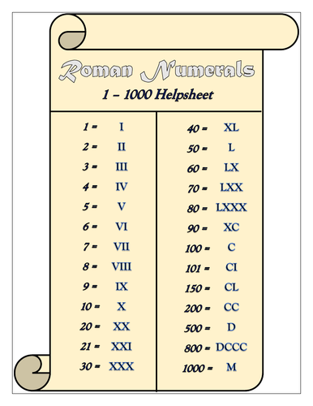](https://www.google.com/url?sa=i&rct=j&q=&esrc=s&source=images&cd=&ved=2ahUKEwiU6vWEoMzkAhVl1-AKHfn3DgsQjRx6BAgBEAQ&url=https%3A%2F%2Fwww.tes.com%2Fteaching-resource%2Froman-numerals-1-1000-helpsheet-11787453&psig=AOvVaw38RhIP6oWsxvDUF6JmEDP8&ust=1568410775078521)

