Religious Education

We will continue to lead enquiry based RE lessons, with the children exploring answers to some key questions. Our learning will look at Christianity, another world religion and a worldview (Humanism).

In the first half term we will find answers to the question ‘Why do Christians call Jesus’ day of dying, Good Friday?’ and in the second half term, Maple class will be joined by Sandy Reid and understand where religious beliefs come from.

French

We will continue to look at some basic French such as relatives, rooms of a house, French pronunciation of countries and putting together simple sentences.

PSHCE

Looking after the environment – Plastic pollution, welfare of animals and humans, global challenges. Spaces for reflection and relaxation. Bullying – unacceptable behaviour, what to do and who to turn to. Mental health.

**Maple Class**

**Years 3 / 4**

**Spring Term 2020**

**Seaside**

**Mr. Gachowicz / Miss. Claxton**

[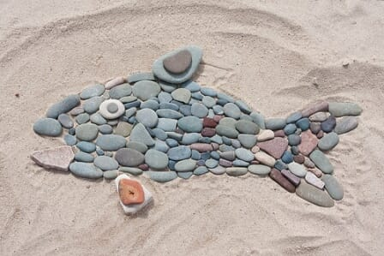](https://www.google.com/url?sa=i&url=http%3A%2F%2Fbloggersandfamily.com%2Fblog%2F2018%2F09%2F24%2Fland-art-para-ninos-otono%2Fpez%2F&psig=AOvVaw3slFojzUk9NgwOqxoXvehk&ust=1575576241322000&source=images&cd=vfe&ved=0CAIQjRxqFwoTCMj7lIblnOYCFQAAAAAdAAAAABAN)

Art/DT

We will look at beach art and how natural materials can be used to create sculptures and look into the work of some famous beach artists.

We will create old-fashioned Seaside advertising posters using simple design, block colour and bold fonts. We will paint Pointillism inspired artwork using dots.

In Design Technology we will build seaside attractions such as fun fair carousels.

Music

Our focus this term will be looking at music that relaxes us. What natural sounds can be found at the seaside? Such as the sound of waves and whale song. How can we imitate these with musical instruments and compose our own piece of music inspired by nature?

Computing

We will use the computers to design a postcard, using images sourced from the internet to put onto our postcards and using templates in Word. We will look at maps and images of UK seaside locations and locate them on a map.

Topic

This terms topic will be The Seaside. Children will learn about the history of the traditional seaside town and how this has changed since the Victorian times. We will learn about the natural features of the coastline and investigate key human geography such as land use and settlements in the UK and the importance of the railway. This topic will allow us to study a local area, with a planned trip to Hunstanton.

English

This term we will be linking our writing to our topic :

* Poetry based on the Seaside
* Ted Hughes ‘How the Whale Became’ – writing our own narratives based on sea creatures
* Postcards from our visit to Hunstanton
* Persuasive writing - looking after the ocean and plastic pollution

We will continue to have weekly SPAG sessions learning the year 3 and 4 objectives, spellings including spelling rules, homophones and words from the national curriculum spelling list and guided reading sessions.

Science

Over the term we are going to be learning about forces and magnets.

Children will learn what a ‘force’ means and understand how they act in the world. We will investigate how objects moves on different surfaces and what forces are at work here, how forces influence the tides and exploring water and air resistance.

We will investigate everyday materials and whether they are attracted to a magnet, how magnetic forces can act at a distance and learn that magnets have two poles.

We will continue to use scientific vocabulary, ask questions and lead enquiries and conduct experiments with variables and fair testing.

Maths

Year 3

We will be looking at fractions and counting up and down in tenths, recognising and writing fractions of amounts using unit and non-unit fractions, looking at equivalent fractions and adding and subtracting fractions with the same denominator.

Year 4

We will build on the children’s knowledge of fractions and introduce decimals, looking at equivalent fractions, counting up and down in hundredths, recognising and writing decimal equivalents and rounding decimals to the nearest whole number.